**Cerner to PatientSafe ORU Requirements**

**Version 1.1**

**Prepared By: Levy Lazarre**

**Date: 7/30/2019**

Document Control 3

Resources 3

Project Distribution List 3

Document Version Control 3

1. Introduction 4

1.1 Purpose 4

1.2 Project Scope 4

1.3 Terminology Standards 4

1.3.1 Acronyms 4

1.3.2 Glossary 4

1.4 Document References 4

2. Diagram 5

3. Requirements 6

3.1 Functional Requirements 6

3.2 Non-Functional Requirements –N/A 8

3.3 Messaging Protocols 9

3.3.1 Inbound to the BayCare Cloverleaf From Cerner 9

3.3.2 Outbound to PatientSafe 9

4. HL7 Messaging 9

4.1 Messaging Format 9

4.1.1 Segments 9

4.1*.*2 Messaging Event Types 10

4.1*.*3 Cloverleaf Configuration Files 10

4.1.4 Cloverleaf Site Location 10

4.2 Data Transformation Requirements 11

4.3 Sample Message 11

Appendix A: Risks and Concerns 12

Appendix B: Issues List 12

# **Document Control**

## Resources

|  |  |  |
| --- | --- | --- |
| **Name** | **Role** | **Email** |
| Derek Richae | Innovation Analyst  Project Manager, BayCare | Derek.Richae @baycare.org |
| Blake Basquin | Senior Project Manager  PatientSafe Solutions | bbasquin@patientsafesolutions.com |
| Sean Payne | Principal Software Solutions Engineer  PatientSafe Solutions | SPayne@patientsafesolutions.com |
| Urvashi Parmar | Associate Software Engineer  PatientSafe Solutions | UParmar@patientsafesolutions.com |
| Sailaja Parimi | Integration Analyst, BayCare EIT | Sailaja.Parimi @baycare.org |
| Levy Lazarre | Integration Analyst, Baycare EIT | Levy.Lazarre@baycare.org |
| Vanja Karabasic | Systems Analyst  APPS – DOCUMENTATION/ORDERS | Vanja.Karabasic @baycare.org |
| Janet Dowell | Systems Analyst – DEPT SPEC  LAB COMPUTER | Janet.Dowell@baycare.org |
| Pattie D. Cone | IT Lead - CBO  CBO MANAGEMENT SUPPORT | Patricia.Cone@baycare.org |

## Project Distribution List

## Document Version Control

|  |  |  |  |
| --- | --- | --- | --- |
| **Version** | **Date** | **Modifier** | **Description** |
| V1.0 | 01/28/2019 | Levy Lazarre | Original document |
| V1.1 | 07/30/2019 | Yitzhak Magoon & Tiffany Bohall | Updated document for Cerner Model |
|  |  |  |  |
|  |  |  |  |

# 1. Introduction

## 1.1 Purpose

The purpose of this document is to describe the ORU Interface going from Cerner EMR to PatientSafe Solutions.

**PatientTouch** is a PatientSafe application used by physicians, nurses, and other clinicians for collaboration in patient care. It runs on a smartphone and consolidates secure messaging, voice, alerts, and nurse calls with EMR data and clinical workflows in one mobile app on one device.

## 1.2 Project Scope

The scope of this project is to automate the integration of the PatientSafe Solutions PatientTouch application with the Soarian HIS via HL7 ADT interface and the Cerner EMR via HL7 ADT and Results interfaces. There is also integration of Orders via Sansoro API. **The current document describes the ORU interface from Cerner EMR to PatientSafe for the purpose of sending patient lab results to PatientSafe.**

## 1.3 Terminology Standards

### 1.3.1 Acronyms

**ADT** – Admission, Discharge, Transfer: mainly demographic and patient location data

**HIS** – Health Information System, the source and keeper of patient demographic data

**PSS** – PatientSafe Solutions

### 1.3.2 Glossary

**ORU Event** – Trigger event associated the unsolicited transmission of an observation message

## 1.4 Document References

1. IP_Baycare_Workflow_101718.pdf

2. ADT Test cases.rev0-20181126.xlsx

# 2. Diagram

Provide a solution diagram that depicts the integration of components specified in this IDBB. This diagram must include the data flow for the interfaces (source and target).

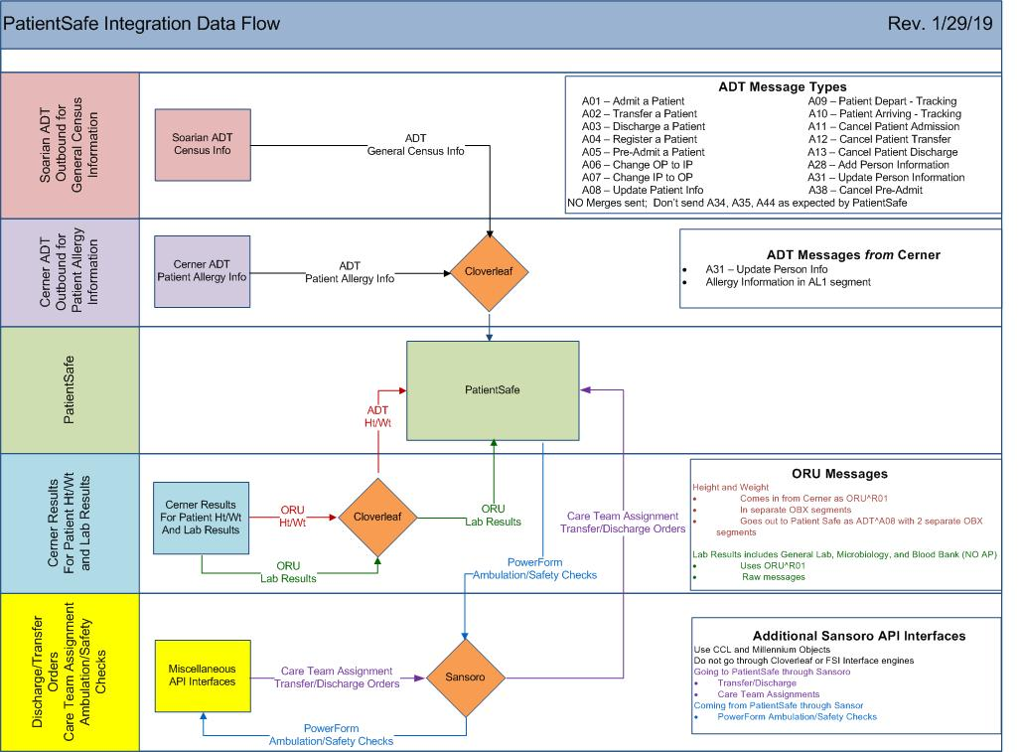

# 3. Requirements

## 3.1 Functional Requirements

Provide detail for the below functional requirements. The message transformation requirements for the components defined in this specification should be specified in section 4.2 of this document.

|  |  |  |
| --- | --- | --- |
| **Cloverleaf** |  |  |
| **Number** | **Requirement Name** | **Requirement Description** |
| FR.2019.7.29.1 | tpsCernerCommonCode  (on inbound tab) | Setting default value of MSH.5.1 to PV1.3.7    Over ride MSH.5 if PV1.18 =JHOUTREACH, hard code SJH to MSH.5.  If PV1.18 =WOOUTREACH, hard code WHH to MSH.5 and PV1.18 =MPOUTREACH, hard code MPH to MSH.5    Remove patient email from PID.11    Iterate through PID.11 looking for Home address and populate just these values outbound in PID.11    Blank our PID.19 is SSN=999999999    Replace & character with the word ‘and’ in OBR.13, OBR.27.7 and OBR.31.2. |
| FR.2019.1.0 | tpsAdvHL7Filter: For the pilot project, only send Mease Countryside Hospital patients to PatientSafe. | Only MCS is included in the pilot project. A Tcl advanced filter is used to only let patients from MCS hospital go to PatientSafe in this first phase. |
| FR.2019.2.0 | tpsAdvHL7Filter: Anatomic Pathology results are not in scope for this pilot phase of PatientSafe implementation. | Only Lab, Microbiology, and Blood Bank results should be sent. A Tcl advanced filter is used to restrict the output to PatientSafe to those 3 activity types based on the value of **OBR.24** in the result message. Acceptable values from Cerner are: **Lab Micro BB**. |
| FR.2019.7.29.2 | tpsHL7ChangeData | Replacing PID.2 with PID.3 |
| FR.2019.7.29.3 | tpsCernerLabResultsModifier  (on inbound tab) | Null PID.5.7    Null various PV1.19 visit number fields:  PV1.19.2  PV1.19.3  PV1.19.4.1  PV1.19.4.2  PV1.19.4.3  PV1.19.5  PV1.19.6.1  PV1.19.6.2  PV1.19.6.3    Swap various ORC.2 and ORC.3 fields:  ORC.2.1 and ORC.3.1  ORC.2.2 and ORC.3.2  ORC.2.3 and ORC.3.3  ORC.2.4 and ORC.3.4    Swap various OBR.2 and OBR.3 fields:  OBR.2.1 and OBR.3.1  OBR.2.2 and OBR.3.2  OBR.2.3 and OBR.3.3  OBR.2.4 and OBR.3.4    If OBX.3.3 =LOINC, swap OBX.3.4 with OBR.3.1 and swap OBX.3.5 with OBX.3.2.  Else, swap OBX.3.4 and OBX.3.1, OBX.3.5 and OBX.3.2 and OBX.3.6 and OBX.3.3. |
| **Cerner** |  |  |
| **Number** | **Requirement Name** | **Requirement Description** |
| FR.2018.01.1 | **ESO Interface Trigger:**  Observation Reporting/ORU Discrete Gen Lab/CE Server GLB/GRP (CQM Class: CE) | This trigger causes the BayCare Laboratory results to be processed outbound when entered in Pathnet as long as the result items are not aliased with DONOTSEND for contributor source INVISION on code set 72.  - The following segments are set to be sent outbound by this trigger:   * HL7 MSH * HL7 PID * HL7 PV1   HL7 OBR/OBX/NTE |
| FR.2018.01.2 | Global Script:  - route_out | route_out (global script): Logic to route BayCare Laboratory results to the ORU_LAB_RESULTS_OUT comserver. Logic is based on:   * Message Type = ORU, cqm_type in “AP”, “MICRO”, or “GRP” * End logic for all ORU messages outbound is sent to these comservers:   - ORU_LAB_RESULTS_OUT |
| FR.2019.07.29.2 | New scripts:  fsi_common (generic)  oru_lab_out (mod object)  fsi_add_pcpe (generic) | oru _lab_out, Mod Object script, for BayCare Laboratory  results outbound:   * Calls the fsi_common generic script to load all subroutines * Adds the correct ordering provider to OBR.16, the correct order name/description to OBR.4, and the correct order alias to OBR.3 for AP results. * Replace any primary care physician (PCP) with the PCP at the encounter level in the PD1 segment. * Deletes any DONOTSEND* result items and renumbers the OBX segments accordingly. *Note: This is a known Cerner issue where LOINC coding overrides the DONOTSEND functionality. Custom Coding was needed to fix the issue.   Filters all ORU messages if there is no OBX segment after the OBX segments are stripped as described above. |

## 3.2 Non-Functional Requirements –N/A

Provide concise detail for the below non-functional requirements. The below requirements must be evaluated for every project.

|  |  |  |
| --- | --- | --- |
| **Cloverleaf** |  |  |
| **Number** | **Requirement Name** | **Requirement Description** |
| NFR.20XX.1.0 | Click here to enter text. | Click here to enter text. |

## 3.3 Messaging Protocols

Below are listed the details for the messaging protocols that will be leveraged for this integration.

### 3.3.1 Inbound to the BayCare Cloverleaf From Cerner

* TCP MLLP Server Connection

### 3.3.2 Outbound to PatientSafe

* TCP MLLP Client Connection

# 4. HL7 Messaging

## 4.1 Messaging Format

### 4.1.1 Segments

The segments utilized for this interface are:

MSH

[EVN]

PID

PV1

OBR

{OBX}

[{NTE}]

Note that the messages are sent “raw” from Cerner to PatientSafe.

At this point, PSS is not using information from the Z segments.

*Message Construction Notes:*

*[Square Brackets] – Optional*

*{Curly Brackets} – Repeatable*

*MSH – Message Header*

*EVN – Event segment*

*PID – Patient ID segment*

*PV1 – Patient Visit segment*

*OBR – Observation Request segment*

*NTE – Notes and Comments segment*

### 4.1*.*2 Messaging Event Types

Below are the messages types necessary for this integration

Supported ORU Events

|  |  |
| --- | --- |
| **Event Type** | **Description** |
| ORU^R01 | Unsolicited transmission of an observation message |
| ORU^R03 | Unsolicited transmission of an observation message |

### 4.1*.*3 Cloverleaf Configuration Files

For each HL7 interface specified in Section 2 of this document, identify the Cloverleaf Configuration Files: Variants, TCL Scripts, Xlates, etc.

HL7 Variants: None

Xlate: None

TCL Script: tpsCernerCommonCode, tpsAdvHL7Filter.tcl, tpsHL7ChangeData, tpsCernerLabResultsModifier

### 4.1.4 Cloverleaf Site Location

Production = cerner_results_7_p

Test = cerner_results_7

## 

## 4.2 Data Transformation Requirements

tpsHL7ChangeData: Move the BayCare MRN sent by Cerner from PID.2 to PID.3, where PSS expects to find it.

## 4.3 Sample Message

Inbound to Cloverleaf from Cerner: (Inpatient)

MSH|^~\&|HNAM|CERNER|INVISION|BAYCARE|20190718111203||ORU^R01|Q4432202650T5825930142||2.3||||||8859/1

PID|1|2006002474^^^BayCare MRN^MRN|2006002474^^^BayCare MRN^MRN||UCTEST^GENONEONE^^^^^Current||20071231|M||||||||||1006009026^^^BayCare FIN^FIN NBR|||||||0

PV1|1|I|^^^SJN^^Building(s)^SJN||||^TEST^3SURGANES1^^^^^^^Personnel|||||||||||I||||||||||||||||||CD:638671|||SJN||Discharged|||20180801083000

OBR|1|15232744931^HNAM_ORDERID||4900233^CREAT|||20190718110100|||||||20190718110200|Blood&Blood^^^^^Venous Draw|^TEST^3SURGANES1^^^^^^^Personnel||||000002019199000036^HNA_ACCN~74112902^HNA_ACCNID||20190718111157||Lab|F||1^^^20190718110100^^ROUTINE~^^^^^TODAY|||||||||20190718110100

OBX|1|NM|2160-0^CREATININE:MCNC:PT:SER/PLAS:QN:^LOINC^L670671^Creatinine^BCLAB||1.500|mg/dL^mg/dL|0.300-1.300^0.300^1.300|H|||F|||20190718111155||^Holz^Jane^K^^^^^^Personnel|^^^CD:719302443

OBX|2|CE|CD:3244548805^AKI Risk^^CD:3244548805^AKI Risk^BCLAB||Stage 2^Stage 2|||*|||F|||20190718111203||^SYSTEM^Donotchange^^^^^^^Personnel|^^^CD:719302443

NTE|1|RESCOM|Baseline Creatinine value used to calculate AKI Risk is 0.580 collected on 07/18/19 10:36:00

Outbound from Cloverleaf to PatientSafe: (Inpatient)

MSH|^~\&|HNAM|CERNER|MCS|BAYCARE|20190718111203||ORU^R01|Q4432202650T5825930142||2.3||||||8859/1

PID|1|2006002474^^^BayCare MRN^MRN|2006002474||UCTEST^GENONEONE^^^^^||20071231|M||||||||||1006009026^^^BayCare FIN^FIN NBR|||||||0

PV1|1|I|^^^SJN^^Building(s)^SJN|||||||||||||||I|^^^&&^^&&|||||||||||||||||CD:638671|||SJN||Discharged|||20180801083000

OBR|1|^^^|15232744931^HNAM_ORDERID^^|4900233^CREAT|||20190718110100|||||||20190718110200|Blood&Blood^^^^^Venous Draw|||||000002019199000036^HNA_ACCN~74112902^HNA_ACCNID||20190718111157||Lab|F||1^^^20190718110100^^ROUTINE~^^^^^TODAY|||||||||20190718110100

OBX|1|NM|L670671^Creatinine^BCLAB^2160-0^CREATININE:MCNC:PT:SER/PLAS:QN:^LOINC||1.500|mg/dL^mg/dL|0.300-1.300^0.300^1.300|H|||F|||20190718111155||^Holz^Jane^K^^^^^^Personnel|^^^CD:719302443

OBX|2|CE|CD:3244548805^AKI Risk^^CD:3244548805^AKI Risk^BCLAB||Stage 2^Stage 2|||*|||F|||20190718111203||^SYSTEM^Donotchange^^^^^^^Personnel|^^^CD:719302443

NTE|1|RESCOM|Baseline Creatinine value used to calculate AKI Risk is 0.580 collected on 07/18/19 10:36:00

**Go Live Date for PSS ORU interface: January 22, 2019**

# Appendix A: Risks and Concerns

|  |  |  |  |  |  |  |  |  |
| --- | --- | --- | --- | --- | --- | --- | --- | --- |
| **Project Name** |  |  | | |  |  |  |  |
| **Number** | **Risk / Concern** | **Comment** | **Mitigation** | | |  |  |  |
|  |  |  | |  | |  |  |  |

# Appendix B: Issues List

This is a dynamic list of the open issues related to the IDBB that remain to be solved, including but not limited to TBDs, pending decisions, information needed, conflict awaiting resolution, and the like.

|  |  |  |  |  |  |  |  |  |
| --- | --- | --- | --- | --- | --- | --- | --- | --- |
| **Project Name** |  |  | | |  |  |  |  |
| **Number** | **Issue** | **Comment** | **Fix** | | |  |  |  |
|  |  |  | |  | |  |  |  |

* End of document